EE052
PRINCIPLES OF EE1 LAB

LAB 3

Kirchoff’s Current And Voltage Laws

Full name:………………………………..
Student’s ID:……………………….........
Class:……………………………………..
Date:……………………………………...
- OBJECTIVES
      - To study again the relationship of Ohm's Law.
      - To learn and apply Kirchhoff's Current Law (KCL).
      - To learn and apply Kirchhoff's Voltage Law (KVL).
      - To obtain further practice in electrical measurements.
      - To become more familiar with both series and parallel circuits.
      - To learn how to determine "equivalent resistance" for both series and parallel circuits.
- INTRODUCTION
1. Kirchhoff's Current Law (KCL)
KCL states that the algebraic sum of currents leaving any node or the algebraic sum of currents entering any node is zero, or:
i₁ + i₂ + i₃ ...i_{n} = 0
Also KCL can be stated as the sum of the currents entering a node must equal the sum of the currents leaving a node, or:
i₁ + i₂ = i₃ + i₄
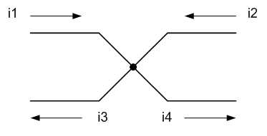
Figure 1
As you make a summation of currents, it is suggested that you use currents leaving the node as positive and the currents entering node as negative, or:
-i₁ - i₂ + i₃ + i₄ = 0
Kirchhoff's Voltage Law (KVL) states that the algebraic sum of voltages around a closed path is zero, or:
v₁ + v₂ + v₃ ... v_{n} = 0
As you make a summation of voltages, it is suggested that you proceed around the closed path in a clockwise direction. If you encounter a positive (+) sign as you first enter the circuit element, then add the value of that. Conversely, if you first encounter a negative sign as you enter the circuit element, then subtract the value of that voltage.
2. Equivalent resistance
The equivalent resistance of resistors in series is expressed as:
R_{eq} = R₁ + R₂ + R₃ ... R_{n}
The equivalent resistance of resistors in parallel is expressed as:
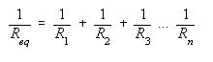
Note: For only two resistors in parallel, the above equation reduces to:
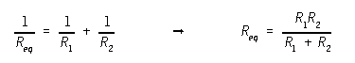
Note also that for resistors of the same value in parallel this reduces to:
R_{eq} = R₁/2 for two resistors
R_{eq} = R₁/3 for three resistors
R_{eq} = R₁/4 for four resistors
etc.
The principle of voltage division can be used for series circuits, and it is stated as follows: The total voltage across a circuit of resistances in series will divide itself in the circuit in direct proportion the resistances.
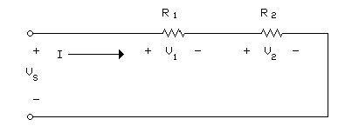
Figure 2
Using voltage division in the circuit shown in Figure 2:
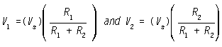
Also the voltages in Figure 2 can be determined by using Ohm's Law, if you know I.
V1 = R1I and V2 = R2I
The principle of current division can be used for parallel circuits, and it is stated as follows: The total current in a circuit of resistances in parallel will divide itself in inverse proportion to the resistances. Using conductance instead of resistance Where G1 = 1/R1 and G2 = 1/R2 the currents divide in direct proportion to the conductances.
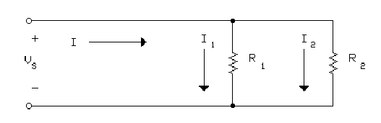
Figure 3
Using current division in the circuit shown in Figure 3:
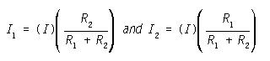
or I₁ = G₁/(G₁ + G₂) and I₂ = G₂/(G₁ + G₂)
Also the currents in Fig. 2 can be determined by using Ohm's Law.
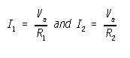
PRE-LAB

- Given the circuit 3. Vs is 19V. Calculate Is, I₁, I₂, I₃, I₄, I₅, I₆
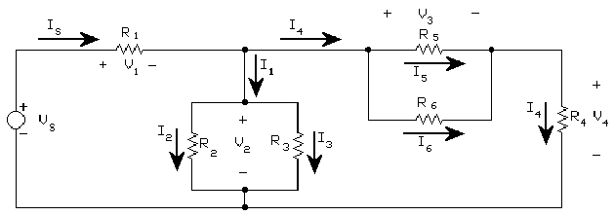
CIRCUIT 3
R1 = 1.2 kΩ, R2 = 3.3kΩ, R3 = 3.3 kΩ,
R4 = 2.7 kΩ, R5 = 5.6 kΩ, R6 = 4.7 kΩ
- Given the circuit 4. Vs is 20V. Calculate I₁, I₂, I₃, I₄, I₅
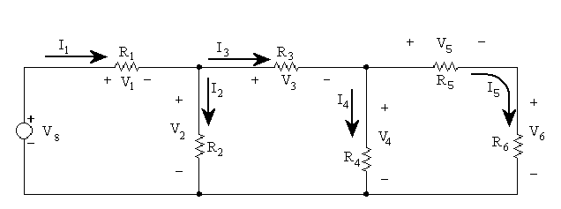
Figure 7: CIRCUIT 4
R1 = 1.2 kΩ, R2 = 5.6 kΩ, R3 = 3.3 kΩ,
R4 = 4.7 kΩ, R5 = 2.7 kΩ, R6 = 1.2 kΩ

- EQUIPMENT AND PARTS LIST
      - Digital Multimeter (DMM).
      - Adjustable D.C. power supply .
      - Circuit bread board.
      - Resistors: 8.2 kΩ, 15 kΩ, 39 kΩ, 820 Ω, 1.5 kΩ, 2.2 kΩ , 1.2 kΩ, 2.7 kΩ, 3.3 kΩ, 4.7 kΩ, 5.6 kΩ
- PROCEDURES
1. Kirchoff’s Laws
      - Reminder the make, model number, and serial number of each piece of measuring equipment is required on every experiment.
      - Note the color code on each resistor and match it up with its nominal value from the color code cards (stuck on the table).
      - Measure and record the actual value for each resistor. Make a tabulation showing nominal value versus the measured value. Are the measured values within the specified tolerance of the nominal values?
      - Using the adjustable D.C. power supply and circuit bread board, connect the resistors into a two node circuit as shown below. Note that all four circuit elements are connected between those two nodes, and the source voltage V_{s} is across each of the three resistors. Let R₁ = 8.2 kΩ, R₂ = 15 kΩ, and R₃ = 39 kΩ.
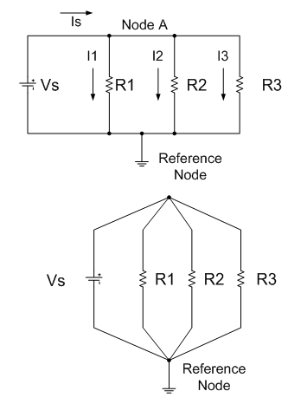
Figure 4: CIRCUIT 1
      - Measure all four currents, (Is, I1, I2, and I3), in your actual circuit with Vs = 16 V D.C. Record the actual measured value of the voltage difference between the two nodes.
      - Using the adjustable D.C. power supply and the circuit bread board, connect the resistors into a circuit as shown below. Note that the three resistors are in series so that the same current (Is) flows thru each resistor.
Let R₁ = 1.5 kΩ, R₂ = 820 Ω, and R₃ = 2.2 kΩ
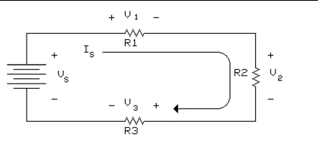
Figure 5: CIRCUIT 2
      - Set the power supply to Vs = 20 V D.C. measure the all four voltages in your actual circuit. Also measure Is.
CALCULATIONS AND COMPARISONS
- In Circuit 1, use your measured current values to determine if KCL is verified to within the limits of the measuring equipment. Also use Ohm's Law and nominal resistance values to calculate I1, I2, and I3 and then use KCL to calculate Is. Repeat the calculations using the measured resistance values. Make a chart to compare measured current values with the two sets of calculated values. Include the % differences in this chart. Are the differences between the measured values and the values calculated using the measured resistance values within the accuracy limits of the DMM? Are the differences found using the nominal values for calculations within the tolerance limits of the resistors?
- In Circuit 2, use your measured voltage values to determine if KVL is verified is verified to within the limits of the measuring equipment. Also use measured value of Is, measured values of resistance, and Ohm's Law to calculate V1, V2, and V3. Make a chart to compare these calculated voltage values with the measured voltage values. Are all differences within the expected limits of accuracy?
2. Series-parallel circuit
- Using the adjustable D.C. power supply and circuit bread board, connect the resistors into a circuit conforming to Circuit #3 below. Make sure you record the actual value of each resistor used along with the position in which it was used.
Figure 6: CIRCUIT 3
R1 = 1.2 kΩ, R2 = 3.3kΩ, R3 = 3.3 kΩ,
R4 = 2.7 kΩ, R5 = 5.6 kΩ, R6 = 4.7 kΩ
- Measure and record all the currents and voltages in Circuit 3 setting Vs close to 19 V DC. Measure and record I4 , I5 , & I6 twice.
- Connect Circuit 4 as shown below.
Figure 7: CIRCUIT 4
R1 = 1.2 kΩ, R2 = 5.6 kΩ, R3 = 3.3 kΩ,
R4 = 4.7 kΩ, R5 = 2.7 kΩ, R6 = 1.2 kΩ
- Measure all the currents and voltages in Circuit #4 setting Vs close to 20 V D.C.
CALCULATIONS AND COMPARISONS:
- Using methods presented in BACKGROUND AND THEORY plus the attached reference example, calculate the theoretical values of currents and voltages using the measured values of resistances and Vs for both Circuit #3 and Circuit #4.
- Make a table to compare measured values with theoretical values and include the % difference for each voltage and current.
- Apply KVL to each loop and KCL to each node. How closely do the voltages and currents add up to the values predicted? Which current range gave the most accurate values for I4 , I5 , & I6 in circuit 3?
- Were Kirchoff's laws verified to within the accuracy of the meter used? Show how you can demonstrate the overall accuracy of the experiment.

